Section B
 |  |  |  |  |  | Leave blank
Question 07
0 | 7 | . | 1 | in_string = input("Please enter text to compress: ") + " "  run_length_encoded = ""  current = ""  count = 1  for i in range(len(in_string) - 1):  if not current:  current = in_string[i]  if current == in_string[i+1]:  count += 1  else:  run_length_encoded += f"{current} {count} "  current = ""  count = 1  print(run_length_encoded.strip())
0 | 7 | . | 2 | 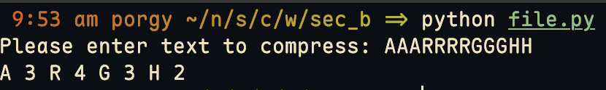
0 | 7 | . | 3 | 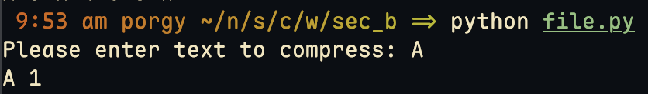
 |  |  |  |  |  | 14

